**CURRICULUM VITAE**

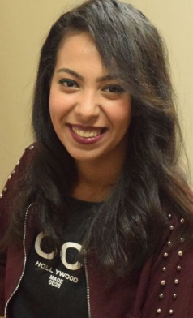**Personal information:**

**Name : Marina Fathi Zenhom**

**Nationality : Egyptian**

**Date of Birth : 2/8/1998**

**Marital status : Single**

**E-mail : rinafathii@gmail.com**

**Contact Address :**

**Home Address : Bani Hussein ,Assuit egypt**

**Mobile : 01276704749**

**Eduction :**

**Graduated from faculty of pharmacy class 2021 Assuit university with excellent grading and the fourth of batch 56**

**Experiences :**

**worked at hanan roman pharmacy**

**Language skills :**

**Arabic : Native language**

**English : very good written – spoken**

**Personal skills**

* **Has ability to learn new tasks quickly**
* **Able to work well with a team work**
* **Able to work well with all level managements and people**

**Computer skills : very good user of office package application ..**

**Courses: English .. human development**

**Hobbies : reading ..traveling ..listening to music**

**Objective :**

**I am aiming to be a professional medical representative**

**Looking for a challenging position and make my company at highest position and market share as possible as I can**

**Thanks for giving me this precious time of yours**